**DTMF Circuit**

**Description**

The DTMF (Dual Tone Multi-Frequency) is used in telecommunication signaling. This converts the superposition of 2 audio tones of different frequencies to binary. This is defined in the table below

|  |  |  |  |  |
| --- | --- | --- | --- | --- |
| **Frequency(Hz)** | **1209** | **1336** | **1477** | **1633** |
| **697** | 1(0001) | 2(0010) | 3(0011) | A |
| **770** | 4(0100) | 5(0101) | 6(0110) | B |
| **852** | 7(0111) | 8(1000) | 9(1001) | C |
| **941** | * | 0(1010) | # | D |

**Table 1: DTMF converter table**

NB: For the purpose of our use BLUEsat does not utilise non-numerical characters

**Purpose**

Through the DTMF dial pad the user is able to provide root level commands in the form of the combination of dial tones. The DTMF converts these signals to binary that will be fed into the GPIO pins of the UART. Thus, the DTMF is connected to the audio receiver and the DTMF output is connected to the Critical Systems Computer.

**Design and Implementation**

The Zarlink MT8870L integrated circuit was selected due to its low power characteristics and it's ability to operate at 3.3v. An alternative was the Holtek HT9170B.

The circuit is based on the recommended configuration for single ended input according to the MT88L70 datasheet (see page 7, Figure 6), and consists of two MT88L70 chips with a common input.

Noting the circuits for U1 and U2 in the schematic are identical:

The component values are:

|  |  |  |
| --- | --- | --- |
| **Components** | **Values** | **Description** |
| **R5, R7** | 100k**Ω** | Since the receiver outputs a 0-3.3V into the DTMF hence a 3.3V output is required. For the internal op amp to produce unity gain we choose both resistor values to be same. |
| **R6** | 300k**Ω** | The RC time constant is determined by a combination of resistors and capacitors. Thus the resistors are the elements used to control the steering input by controlling the time required to wait for input from the receiver. Furthemore, the Early steering output (ESt) notifies Critical Systems Computer (CSC) of input from the receiver being decoded. |
| **C13** | 100nF | The RC time constant is determined by a combination of resistors and capacitors. Thus the capacitors are the elements used to control the steering input by controlling the time required to wait for input from the receiver. Furthemore, the Early steering output (ESt) notifies Critical Systems Computer (CSC) of input from the receiver being decoded. |
| **C12** | 100nF | This capacitor blocks out noise from the reviever output |
| **C15, C16** | 18pF | Since the X2 crystal oscillator is not ideal the capacitors are placed in shunt with the crystal oscillator to rid noise |
| **C14** | 100nF | This capacitor decouples the power supply |
| **X2** | 3.579545 MHz | Crystal oscillator used to drive the sequential circuit in the MT88L70 |

**DTMF Circuit**

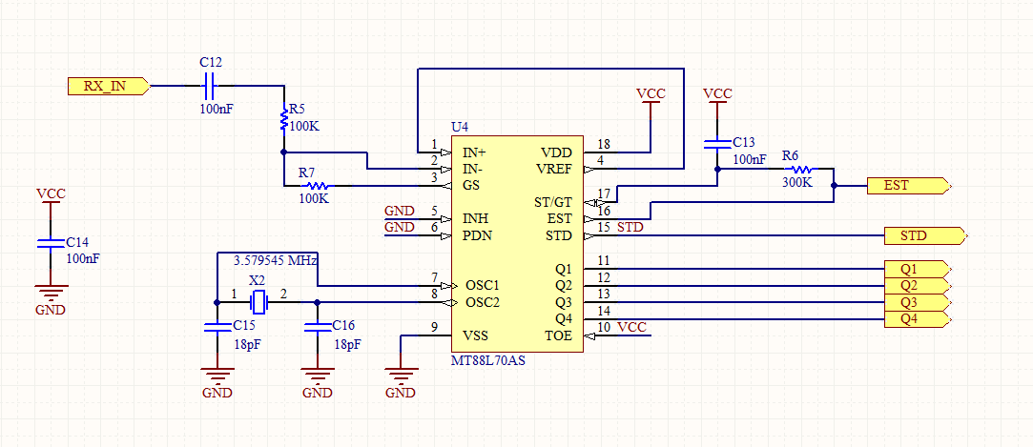

**Connections diagram (for headers)**

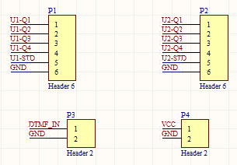

**Notes**

MSB is Q4

LSB is Q1

**Testing**

The DTMF circuit was tested under laboratory conditions and proven successful. The tests performed used the DTMF dial tone pad to generate an input to the circuit and the binary output generated by the DTMF circuit was compared with the expected output (depicted in table 1). Testing for all possible inputs yielded a successful decoding. However, further testing will be conducted by introducing non-idealities such as noise and unexpected input.